**Diagramas Bpmn**

file:///C:/Users/Usuario/Documents/VPProjects/index.html

[Visual Paradigm Project Publisher](https://www.visual-paradigm.com/)

file:///C:/Users/APRENDIZ/Documents/VPProjects/index.html

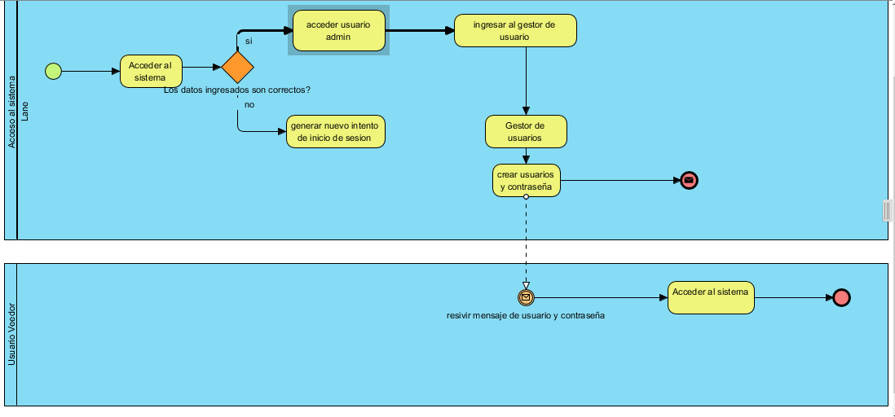

C:\Users\APRENDIZ\Documents\VPProjects

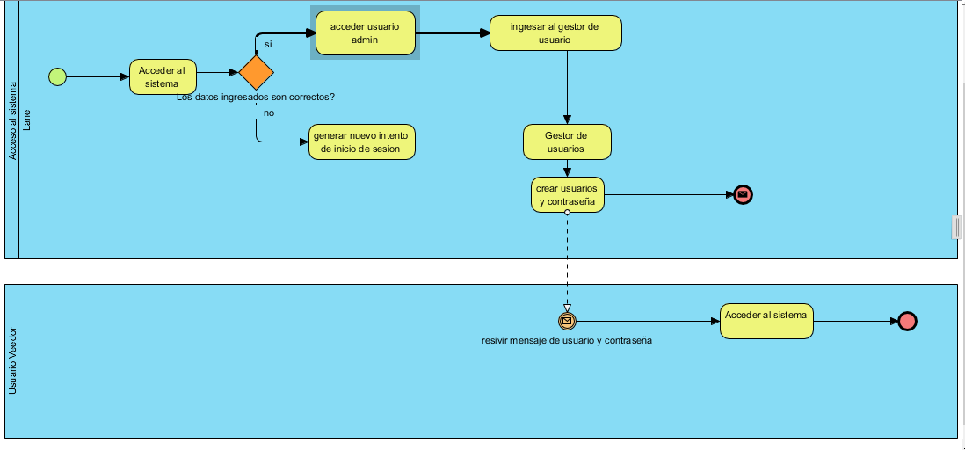

C:\Users\APRENDIZ\Documents\VPProjects

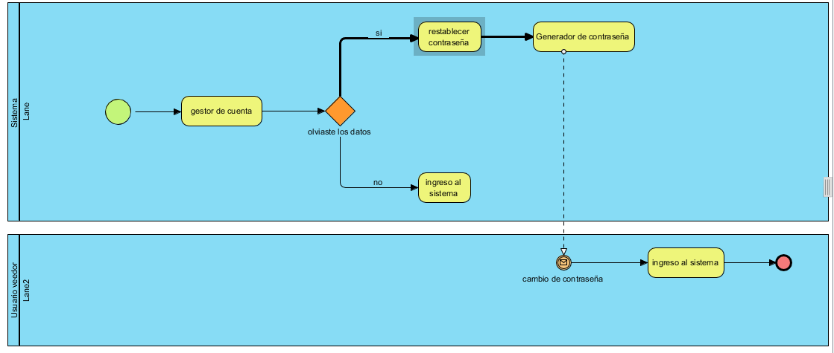

C:\Users\APRENDIZ\Documents\VPProjects

C:\Users\APRENDIZ\Documents\VPProjects\index.html

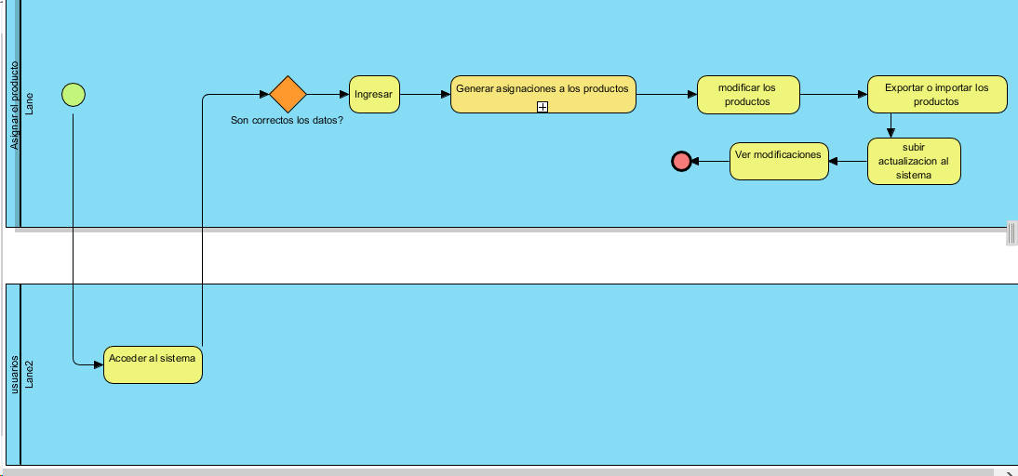

C:\Users\Usuario\Documents\VPProjects

[Visual Paradigm Project Publisher](https://www.visual-paradigm.com/)

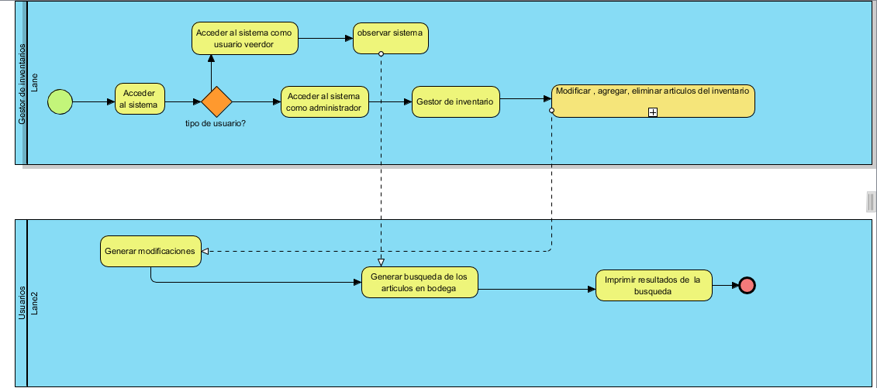

C:\Users\Usuario\Documents\VPProjects

file:///C:/Users/Usuario/Documents/VPProjects/index.html

